DIVISION

TEMPLATES AND GUIDESFG

SNMPv3 provides the additional encrypted authentication and messaging that the mighty 2nd ID's security posture requires. Configure the following in order to properly engage SNMPv3 on any capable device.

ON THE TARGETED DEVICE:

!

snmp-server engineID local 1234567890

!

snmp-server ifindex persist

!

snmp-server group DIVISION v3 priv access SNMP

!

snmp-server user PRIMARY DIVISION v3 auth sha @uthP@$$ priv aes 128 Pr!vP@$$

!

snmp-server host 100.100.4.104 version 3 priv PRIMARY

!

(TO ESTABLISH YOUR ORION INSTANCE AS ANOTHER SNMP-HOST CONIFGURE THE BELOW WHERE **X.X.X.X** IS YOUR ORION INSTANCE)

snmp-server host **X.X.X.X** version 3 priv PRIMARY

IN SOLARWINDS ORION NTA

1. Navigate to the "NETWORK" tab, and then select the "MANAGE NODES" button.

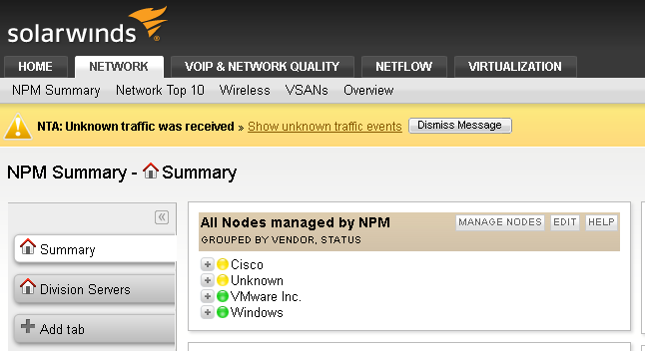

2. Click "Add Node" to add a monitored node.

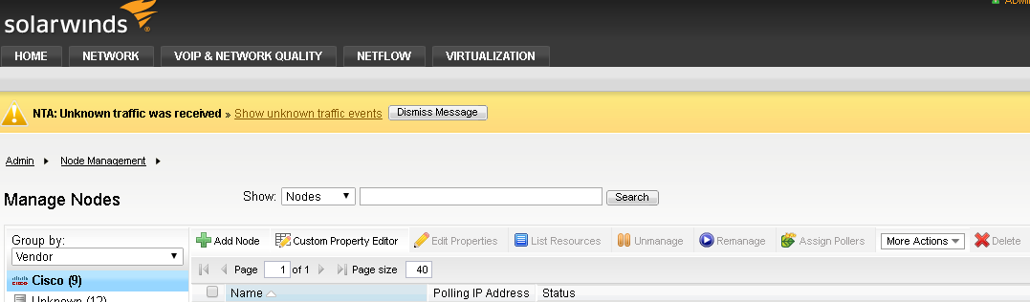

3. This is a 4 step process wherein you must

a. DEFINE THE NODE

b. CHOOSE RESOURCES

c. ADD POLLERS (optional)

d. CHANGE PROPERTIES AND FINAL ADD

A. Enter the device reachable IP address, and change the SNMP Version to SNMPv3 via the drop-down menu.

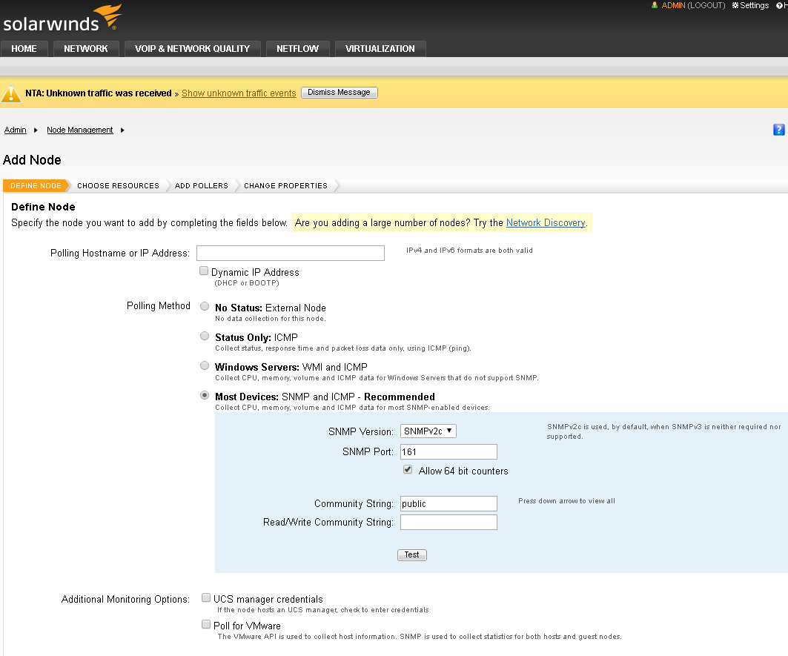

A (cont). The display will change to allow the user to enter SNMPv3 specific entries for authentication and encryption. Enter them as appropriate. Once all options (username, authentication and encryption) are configured, click "Test" to validate your configurations.

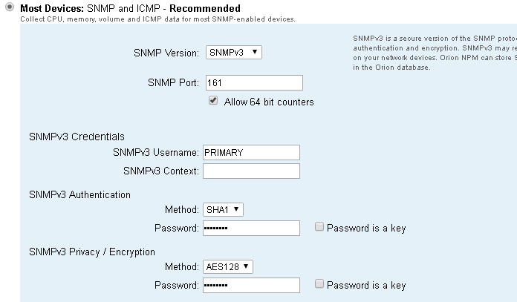

Once you Click "Test" you will see an activity at the bottom of the page stating that Orion is Validating (testing) your configurations.



A (cont). This should result in the following output: Then click "NEXT"



B. System will display the following prompt; which will likely persist for a minute or more.

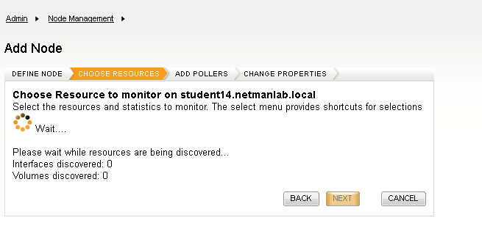

B (cont). Select the resources you would like to monitor / poll for information and then select "NEXT."

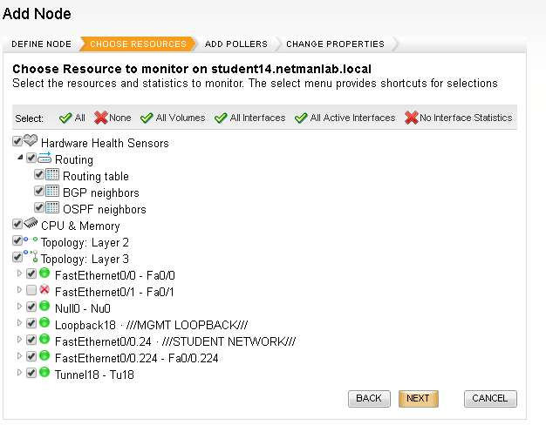

C. Add Universal Device Pollers

D. Change Properties (Finalize).

Change any properties if necessary (not necessary for this exercise).

Click "OK, ADD NODE"

A pop-up should appear:

